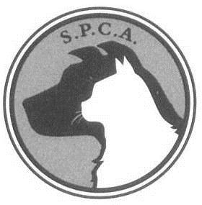
YORKTON SOCIETY FOR THE PREVENTION
OF CRUELTY TO ANIMALS
79 – 7th Avenue South
Yorkton, Saskatchewan, S3N 3V1
306-783-4080

VOLUNTEER SAFETY AGREEMENT
Name of Volunteer: ______________________________________________________________
Address: ___________________________________________________
___________________________________________________
Age: (If under 18) _____________
Phone Number: (Home) _________________ (Work) _________________
(Cell) _________________
INCASE OF EMERGENCY . . .
Contact: ____________________________________________________
Day Time Phone Number: ________________

I hereby give permission to have me child volunteer (if under 18) at the Yorkton S.P.C.A. I understand that while the staff at the shelter will do their best to ensure the safety of my child, the atmosphere of the shelter has some inherent risks and animal behavior can be unpredictable. I therefore release the Yorkton S.P.C.A. from any liability towards my child’s safety.

PARENT’s Signature (if under 18): __________________________________
VOLUNTEER’s Signature: ________________________________________
S.P.C.A. Staff Signature: _________________________________________
DATE: __________________________

Where did you hear about the Yorkton S.P.C.A.?

Why do you want to volunteer?

What do you want to volunteer for?
Shelter/Animal related? ______________ Pet Visits? ______________
Special events (fundraiser events etc.)? __________________________
Any previous volunteer experience? ____________________________
Any experience working with animals? __________________________
Any experience working with the public? ________________________

ATTENTION VOLUNTEERS:
I would like to thank you for your interest in our organization and for your time spent working on behalf of our animals. Being in the proximity of these creatures however, requires some precaution, one being a tetanus inoculation. This is covered by the Saskatchewan Hospitalization Plan and is easily obtained by asking your doctor to make arrangements. The Yorkton S.P.C.A. advises one and all to get it done if they intend on working closely with animals.
Thank - you !

DATE OF LAST TETANUS INNOCULATION: ________________________________

